DOCKER_TASK_1
➔ Task Title
Docker-01
→ Objective
The objective of this task is to watch the Docker-01 video posted on slack and
worked on executing the initializing Ansible shown in video.
→ Prerequisites
List all requirements before starting:
• Virtualization
• Containerization
• Infrastructure
• Hypervisor
• Operation system (O.S) – Windows, Linux, Ubuntu
• Bins/libraries
• Applications
→ Docker:
Docker is a powerful tool for containerization.
What is containerization? And similar to containerization?
Ans. Alternative tools:
• LXC (Linux container)
• Docker
• Podman
→ Difference between Containerization and Virtualization?
Virtualization:
• Virtual machines are dependent on operating system
• Virtual machines will take long time to start up & shutdown.
• Virtual machines size is very high and it is not flexible to move from one
→ environment to another environment.
Containerization:
• Containers are independent of O.S
• Container will be very fast to start up and to shut down.
• Containers size will be very low making them flexible to move from one
→ environment to another env.
Virtualization
App1 App2 App3
bins/libraries bins/libraries bins/libraries
o.s (Ubuntu) Guest o.s (Ubuntu) Guest o.s (Ubuntu) Guest
Hypervisor
Infrastructure
→ Containerization
App1 App2 App3
bins/libraries bins/libraries bins/libraries
Containerization
(Docker, Podman, LXC)
Host Operating system
Infrastructure
Infrastructure- CPU, RAM etc.
→Hypervisor- is a software which will us to create virtual machine.
→ Operating system: Will help us to deploy our application
→ O.S in containerization: We do not require Operating system in
Containerization, instead, we can download the image and test.
When there is no dependencies between O.S and Containerization, the O.S
which has kernels will be shared with bins/libraries.
Tasks:
❖ Setup a virtual machine using Ubuntu image.
❖ Install docker on ec2.
❖ Pull 5 docker images.(nginx,apache
tomcat,ubuntu,jenkins,sonarqube)
❖ Run nginx container and expose on port 81.
❖ Delete the apache tomcat image from local.
❖ Inspect the jenkins image,sonarqube image.
❖ Run jenkins contianer and run one sample job.
1. Setup a virtual machine using Ubuntu image.
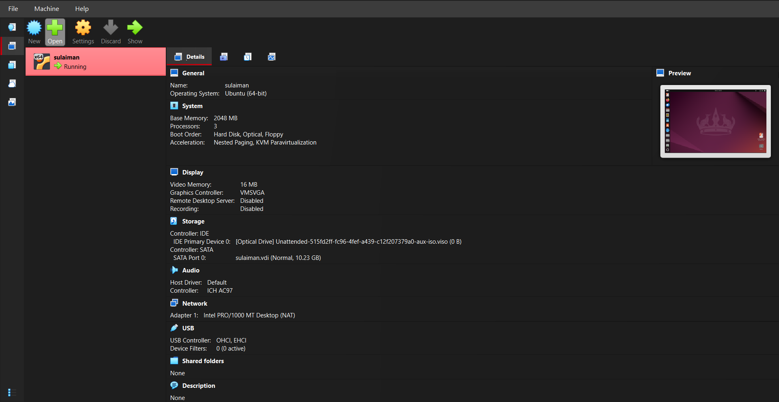
Open our machine
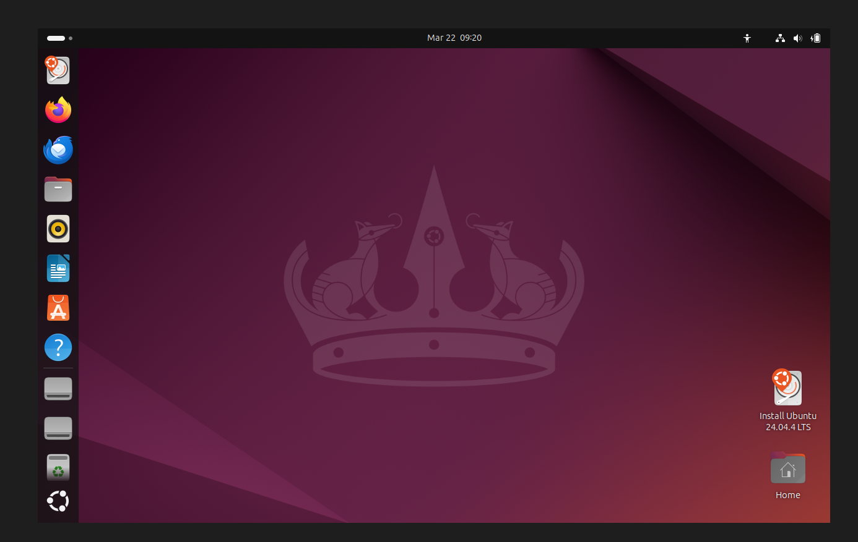
→ Step by step Implementation:
Step 1: Install a virtual machine in ec2 and select Ubuntu image
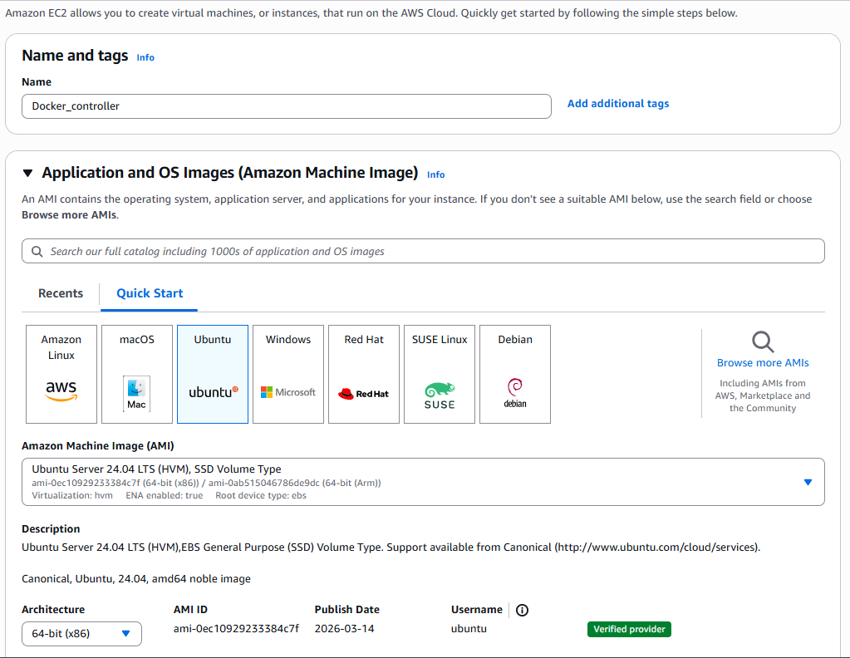
→select t2.large and ubuntu image
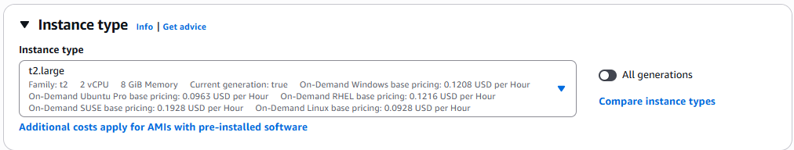
→Select 20Gb as volume
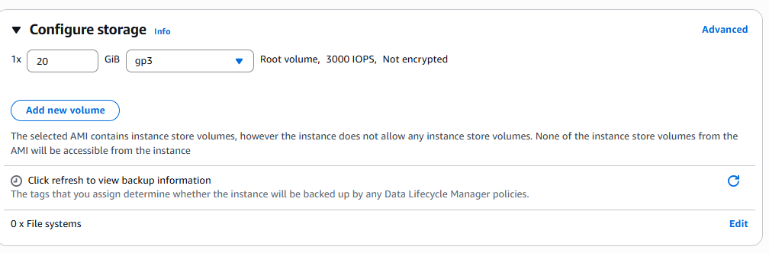
→instance is launched successfully.
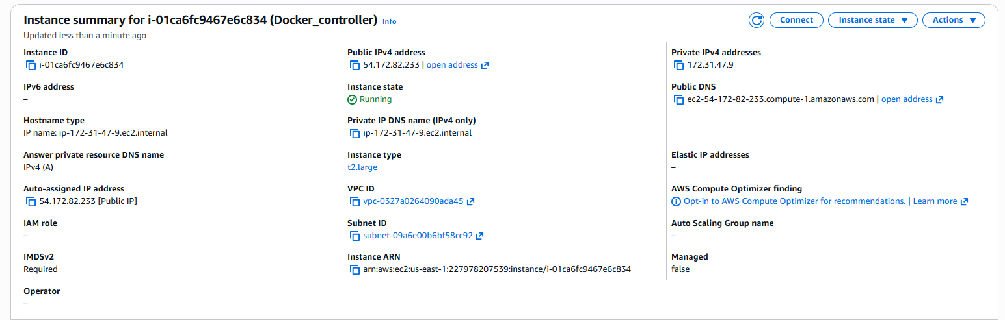
2. Install docker on ec2.
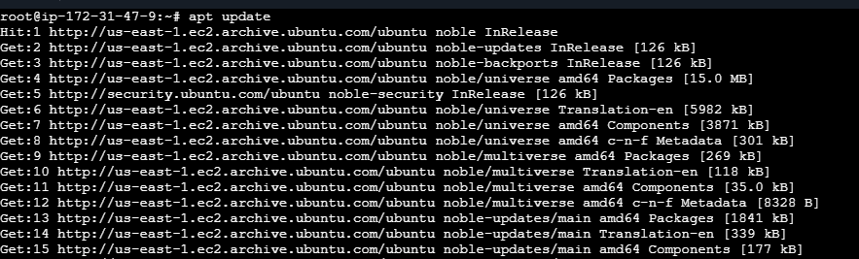
→ apt install docker.io -y
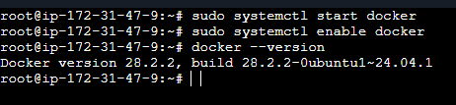
→Now docker is up and running
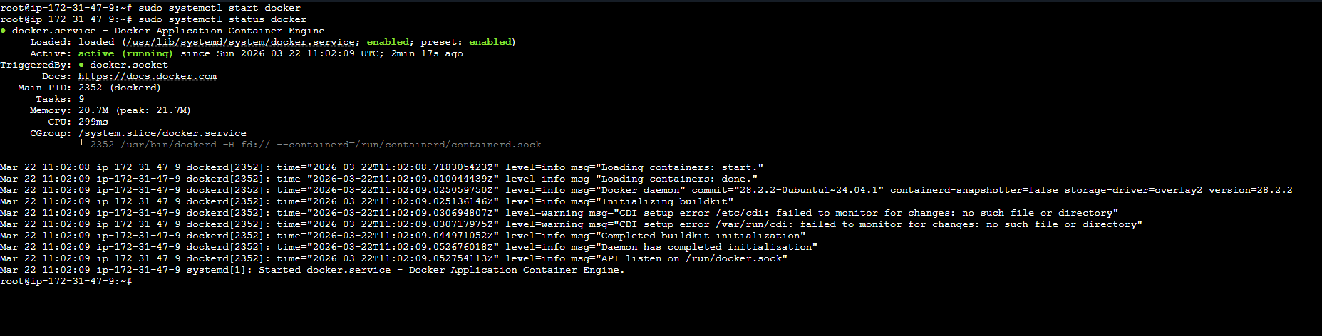
3. Pull 5 docker images.(nginx,apache tomcat,ubuntu,jenkins,sonarqube)
→ Step 1: Service is active → let’s check few commands below
→ Docker pull nginx → this image has been pulled from Docker Hub
→Docker pull nginx
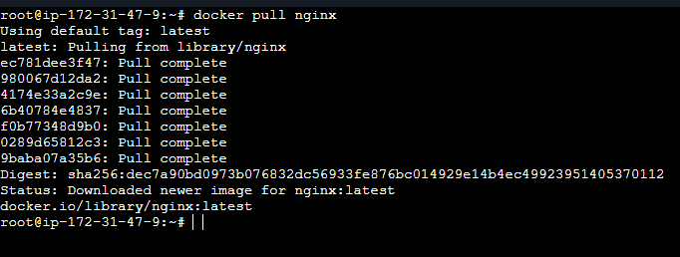
→docker pull httpd
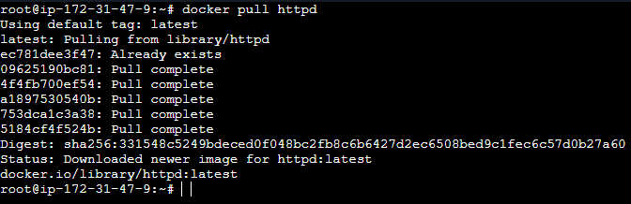
→docker pull tomcat
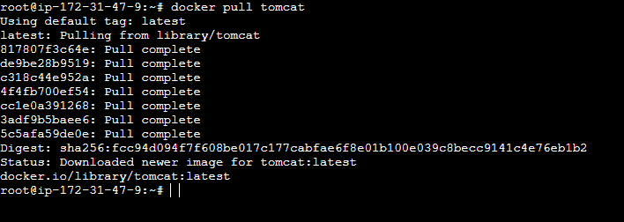
→docker pull ubuntu
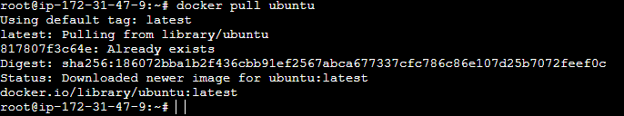
→docker pull Jenkins/Jenkins
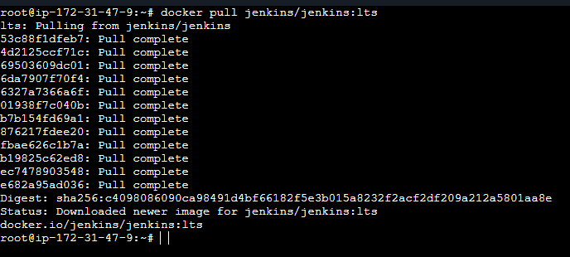

→docker pull sonarqube
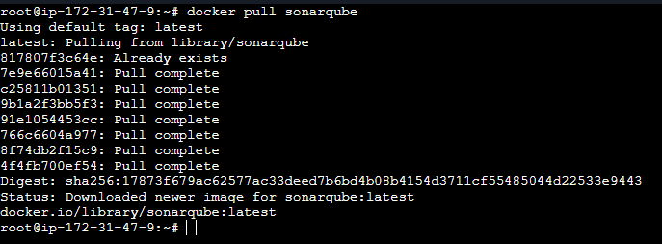
→all docker images are pulled
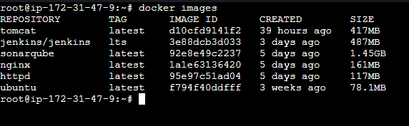
4. Run nginx container and expose on port 81.
→ Step 1: Use command- docker container run -itd -p 81:80 nginx
→docker run -d -p 81:80 nginx.
Run
• Creates a new container
• Starts it immediately
If the image is not present, Docker downloads it first. -d
Detached mode
• Runs the container in the background
• Your terminal stays free
Without -d, nginx logs would block your terminal. -p 81:80
Port mapping (most important part)
Format: -host-port: container-port
So:
• 81 your machine / server port→
• 80 nginx port inside the container→
Meaning:
When someone accesses port 81 on the host, traffic is sent to port 80 inside
the nginx container.
What happens after running this command?
• nginx runs inside a container
• nginx listens on port 80 internally
→Docker exposes it on port 81 externally
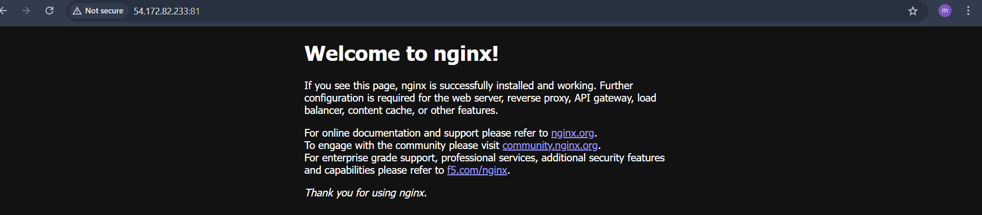
5. Delete the apache tomcat image from local.
→ Step 1: use command- docker ps -a
• Use command- docker images to verify if Tomcat is present
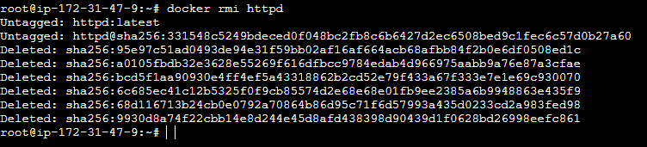
6. Inspect the jenkins image,sonarqube image.
→docker inspect jenkins/Jenkins
→Step 1: Use command- docker image inspect jenkins:2.30.6
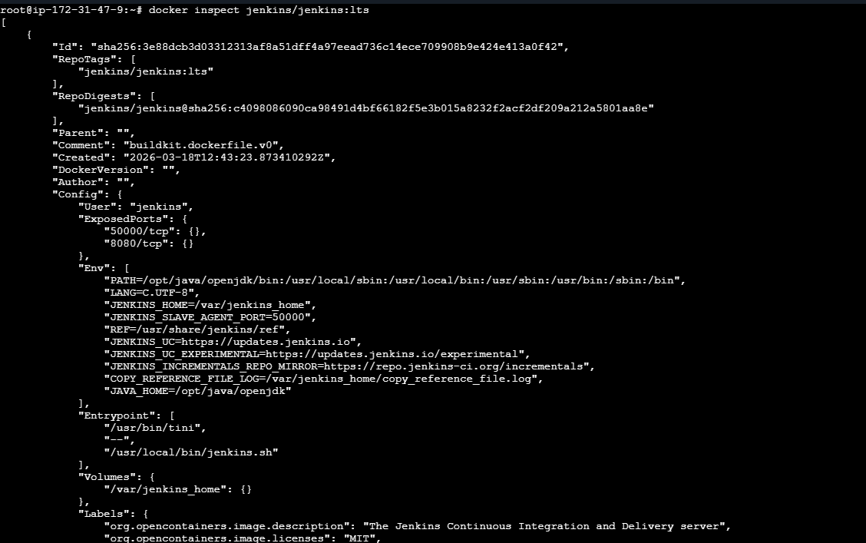
→docker inspect sonarqube
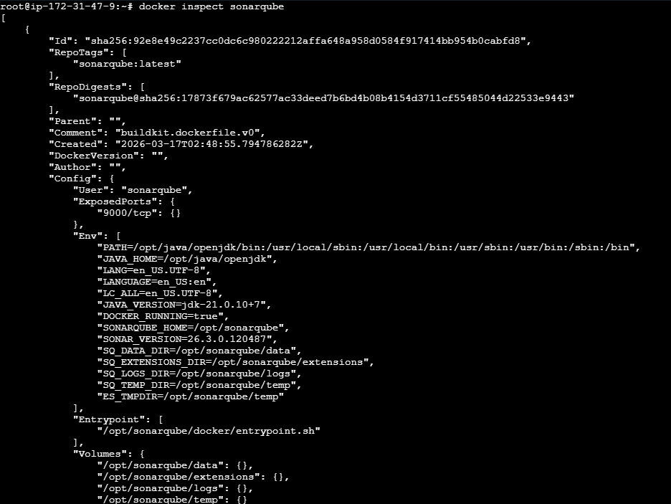
7. Run jenkins contianer and run one sample job.
→docker run -d -p 8080:8080 jenkins/Jenkins
→docker ps
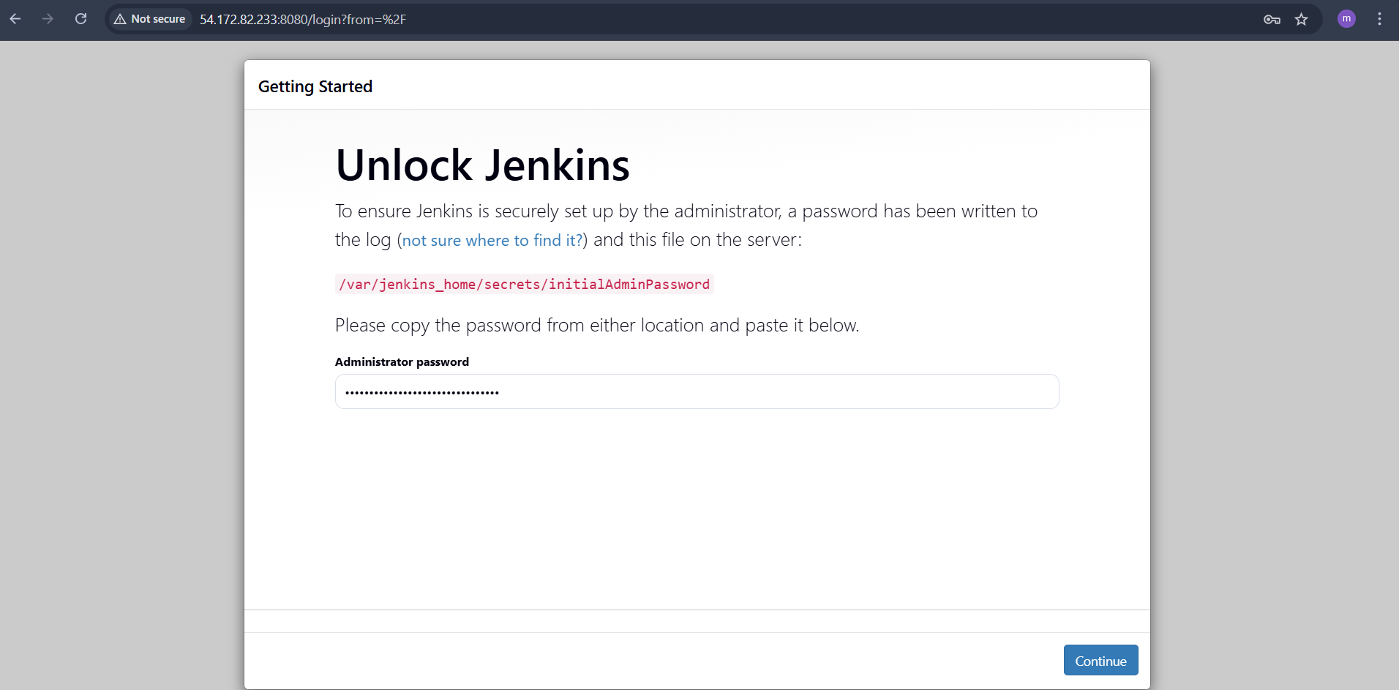
→jenkins gui and set password and run a job
→ docker exec -it 670a6bdf5a2c cat /var/jenkins_home/secrets/initialAdminPassword

